**Week 06-01:**

**Name:Snehan.S**

**Roll no:241801272**

1. Given an array A of sorted integers and another non negative integer k, find if there exists 2 indices i and j such that A[i] - A[j] = k, i != j.

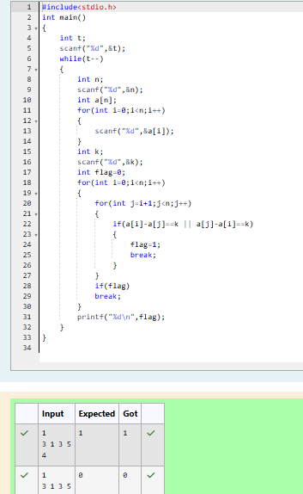

2. Sam loves chocolates and starts buying them on the 1st day of the year. Each day of the year, x, is numbered from 1 to Y. On days when x is odd, Sam will buy x chocolates; on days when x is even, Sam will not purchase any chocolates. Complete the code in the editor so that for each day Ni (where 1 ≤ x ≤ N ≤ Y) in array arr, the number of chocolates Sam purchased (during days 1 through N) is printed on a new line. This is a function-only challenge, so input is handled for you by the locked stub code in the editor

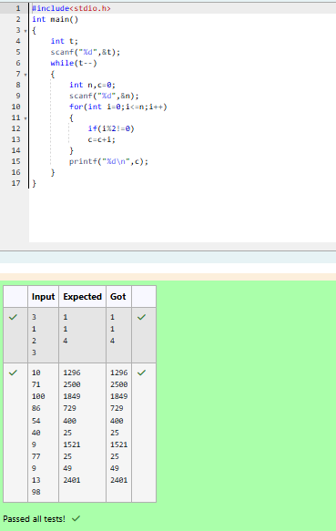

3. The number of goals achieved by two football teams in matches in a league is given in the form of two lists. Consider: • Football team A, has played three matches, and has scored { 1 , 2 , 3 } goals in each match respectively. • Football team B, has played two matches, and has scored { 2, 4 } goals in each match respectively. • Your task is to compute, for each match of team B, the total number of matches of team A, • where team A has scored less than or equal to the number of goals scored by team B in that match. In the above case: • For 2 goals scored by team B in its first match, team A has 2 matches with scores 1 and 2. • For 4 goals scored by team B in its second match, team A has 3 matches with scores 1, 2 and 3. Hence, the answer: {2, 3}. Complete the code in the editor below. The program must return an array of m positive integers, one for each maxes[i] representing the total number of elements nums[j] satisfying nums[j] ≤ maxes[i] where 0 ≤ j < n and 0 ≤ i < m, in the given order.

